MSSQL ASSIGNMENT QUESTIONS (BASIC TRAINING)

Session 1: Understanding DBMS/MSSQL fundamentals & basic queries(~2 hrs)
Classroom-Assignment

Assignment 1:
Create Smart Meter Database Tables
Objective:
Create the database tables needed to store smart meter readings, and customer details.
Instructions:
Write SQL CREATE TABLE statements to define the following two tables:

1. Customers
- CustomerId
- Name (customer name)
- Address
- Region (e.g., North, South, East, West)

2. SmartMeterReadings
- MeterId
- CustomerId
- Location (e.g., rooftop, basement)
- InstalledDate
- ReadingDateTime
- EnergyConsumed

Assignment 2:
Write a query to
Fetch all smart meter readings where:
- EnergyConsumed is between 10 and 50 kWh
- ReadingDateTime is between '2024-01-01' and '2024-12-31'
- Exclude meters installed after '2024-06-30'
OUTPUT FORMAT:
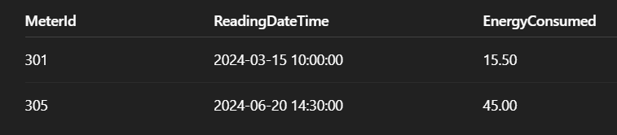

Assignment 3:
For each customer, calculate:
- Average energy consumed per reading
- Maximum energy consumed in a single reading.
Only include readings from the current year.
OUTPUT FORMAT:
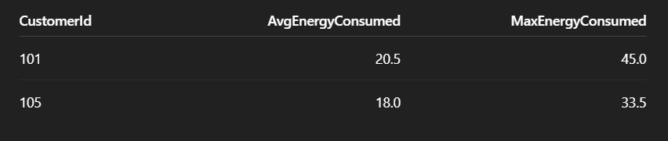

Stretch Goal:
Smart Meter Energy Summary
Objective: Analyse smart meter readings with moderate filtering and grouping.
Write a query to:
- For each meter, calculate:
  - Total energy consumed during peak hours (6 PM to 10 PM)
  - Number of readings recorded during that time
- Only include meters that:
  - Have more than 10 readings in total
  - Were installed before 2025-01-01
- Consider only readings from the current year

OUTPUT FORMAT:
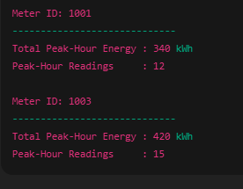

Session 2: Understanding JOINS in MSSQL (~2hrs)
Classroom-assignment

Assignment 1:

Find pairs of customers in the same region (exclude pairing a customer with themselves).
OUTPUT FORMAT:
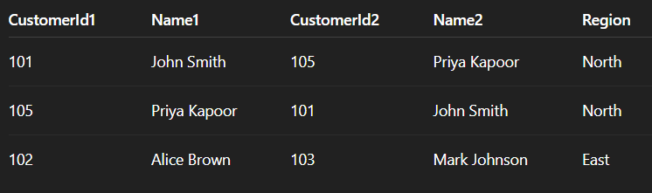

Assignment 2:
List meters with readings over 30 kWh in last 30 days along with customer names.
OUTPUT FORMAT:
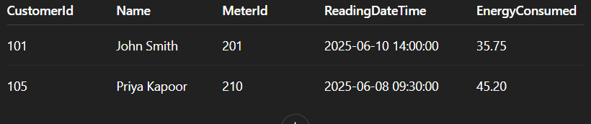

Stretch Goal:
Regional Customer Pair Analysis
Objective: Identify and analyse unique customer pairs within the same region.
Write a query to:
    - Find all unique pairs of customers who:
      - Belong to the same region
      - Have different customer IDs (exclude self-pairing)
      - Were both active in the past 90 days (e.g., LastActiveDate >= DateTime.Today.AddDays(-90))
    - Do not repeat pairs in reverse (i.e., if (A, B) is listed, skip (B, A))
Output Format:
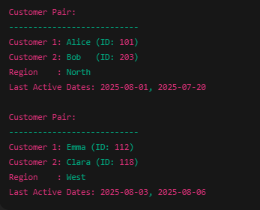

Session 3: Advanced SQL & Window functions(~2hrs)
Classroom-assignment

Assignment 1:

To Find the number of meters installed in each region, but only show regions that have more than 3 meters.
OUTPUT FORMAT:
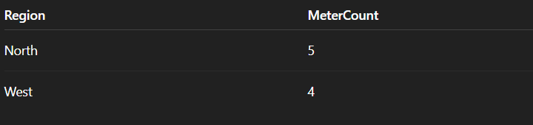

Assignment 2:
Rank each meter per customer by total energy consumed (highest first).
OUTPUT FORMAT:
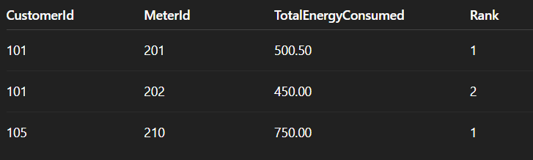

Assignment 3:
For each meter, calculate the cumulative sum of energy consumed ordered by ReadingDateTime.
OUTPUT FORMAT:
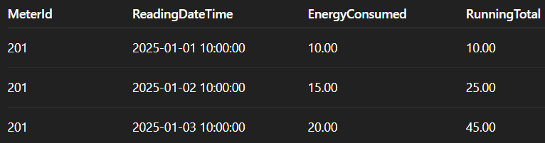

Stretch Goal:
Peak Consumption per Meter
Identify the peak energy reading for each MeterId from the SmartMeterReadings table, using window functions.
For each MeterId, find the reading with the highest EnergyConsumed.
Show:
- MeterId
- ReadingDateTime
- EnergyConsumed
- MeterRank (based on energy consumption per meter using ROW_NUMBER() or RANK())

Output format:
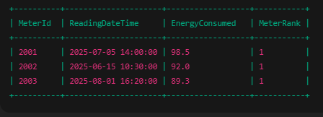

Session 4 : Understanding fundamentals of Stored Procedures(~2hrs)
Classroom-assignment

Assignment 1:
Create a stored procedure that accepts a @CustomerId as input and returns all readings (MeterId, ReadingDateTime, EnergyConsumed) for that customer.
OUTPUT FORMAT: 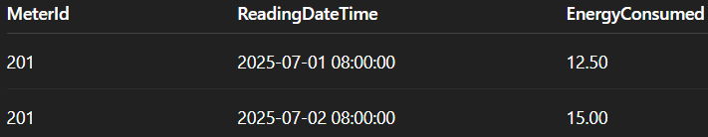

Assignment 2:
Write a stored procedure that takes @MeterId, @ReadingDateTime, and @EnergyConsumed as input, inserts a new reading, and handles errors using TRY...CATCH. If successful, return a message.
OUTPUT FORMAT:

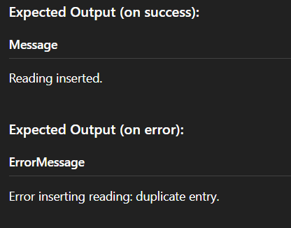

Stretch Goal:
Create a Stored Procedure to Get Monthly Summary
- Procedure Name: GetMonthlyEnergySummary
- Parameters:
    - @Month INT
    - @Year INT
- Requirements:
  - Return:
    - MeterID
    - TotalEnergyConsumed for that month
    - AverageEnergyPerReading
- Only include meters with at least 5 readings in that month
- Sort by TotalEnergyConsumed DESC
Output format:

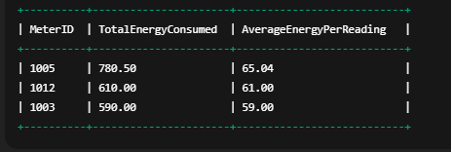

Session 5: Handling transactions in SQL, working with triggers & views(~2hrs)
Classroom-assignment

Assignment 1:
Create an AFTER DELETE trigger on Customers that store deleted customer details into a new table ArchivedCustomers.
OUTPUT FORMAT
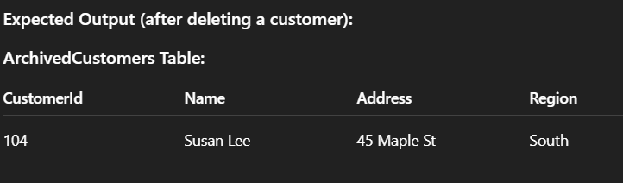

Assignment 2:
Create a view LatestMeterReadings that returns the most recent reading per meter.
Include: MeterId, ReadingDateTime, EnergyConsumed.
OUTPUT FORMAT:

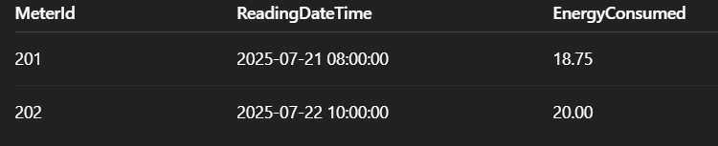

Stretch Goal:
Monthly Energy Analysis View
Objective:
Create a view for monthly tracking of customer energy usage.
Instructions:
- Create a view vw_MonthlyCustomerEnergy that shows:
  - CustomerId
  - Month
  - Year
  - TotalEnergyConsumed
- Use MONTH(ReadingDateTime) and YEAR(ReadingDateTime) in grouping.
Output format:
